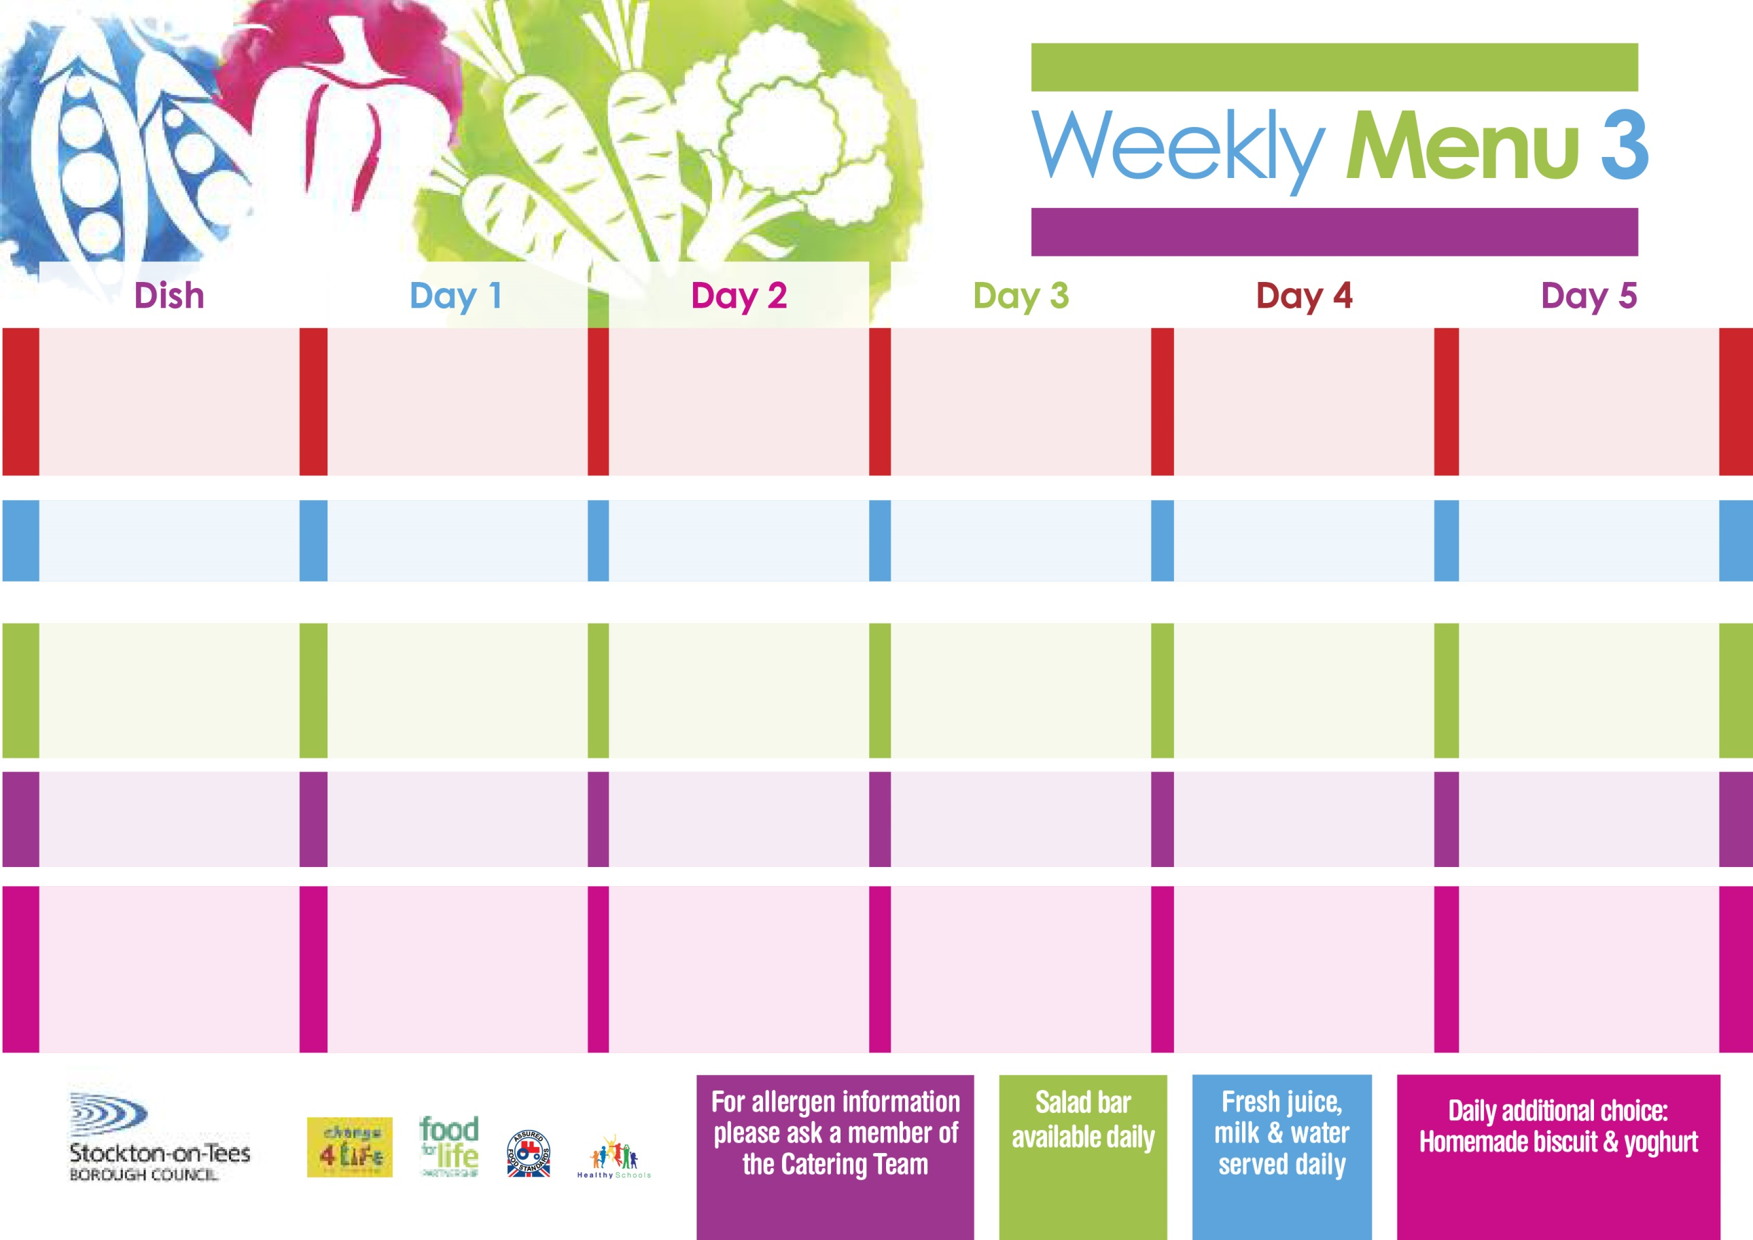

**29th April, 3rd June & 1st July, 2024**

**Mediterranean Bolognaise**

**with Cheesy Bread**

**Mixed Vegetables**

**Quorn Bolognaise (V)**

**Sausage Roll**

**Baked Jacket Potato**

**Spaghetti Hoops**

**Tuna Sandwich**

**Baked Jacket Potato**

**Oaty Apple Crumble**

**with Custard Sauce**

**Cold Bar**

**Fresh Fruit Salad**

**Homemade Pizza (V)**

**Oven Baked Chips**

**Garden Peas**

**Baked Beans**

**Jacket Potato filled with**

**Tuna, Cheese (V)**

**or Baked Beans (V)**

**with Tossed Salad**

**Egg Mayo Sandwich (V)**

**Oven Baked Chips**

**Vanilla Sponge**

**with Custard Sauce**

**Cold Bar**

**Fresh Fruit Bowl**

**Beef Burger in a Bun**

**Oven Roasted Potatoes**

**Baked Beans**

**Garden Peas**

**Quorn Burger in a Bun (V)**

**Salmon & Sweet**

**Potato Fishcake**

**Oven Roasted Potatoes**

**Baked Beans**

**Garden Peas**

**Egg Mayo Sandwich (V)**

**Oven Roasted Potatoes**

**Feathered Sponge**

**with Custard Sauce**

**Cold Bar**

**Fresh Fruit Bowl**

**Chicken Casserole & Dumplings**

**Creamed Potatoes**

**Cauliflower/Swede**

**Quorn Casserole & Dumplings (V)**

**Fish Fillet Fingers**

**Baked Jacket Potatoes**

**Spaghetti Hoops**

**Cheese Sandwich (V)**

**Baked Jacket Potatoes**

**Syrup Roly Poly**

**with Custard Sauce**

**Cold Bar**

**Fresh Fruit Salad**

**Breaded Chicken Breast**

**Oven Roasted Potatoes**

**Garden Peas**

**Diced Carrots**

**Quorn Dippers (V)**

**Corned Beef Pie**

**Oven Roasted Potatoes**

**Garden Peas**

**Diced Carrots**

**Cheese Sandwich (V)**

**Oven Roasted Potatoes**

**Marble Sponge**

**with Custard Sauce**

**Cold Bar**

**Fresh Fruit Bowl**

**Red Choice**

**Blue Choice**

**Green Choice**

**Cold Selection**

**Desserts**

**Wristband Primary School Menu**