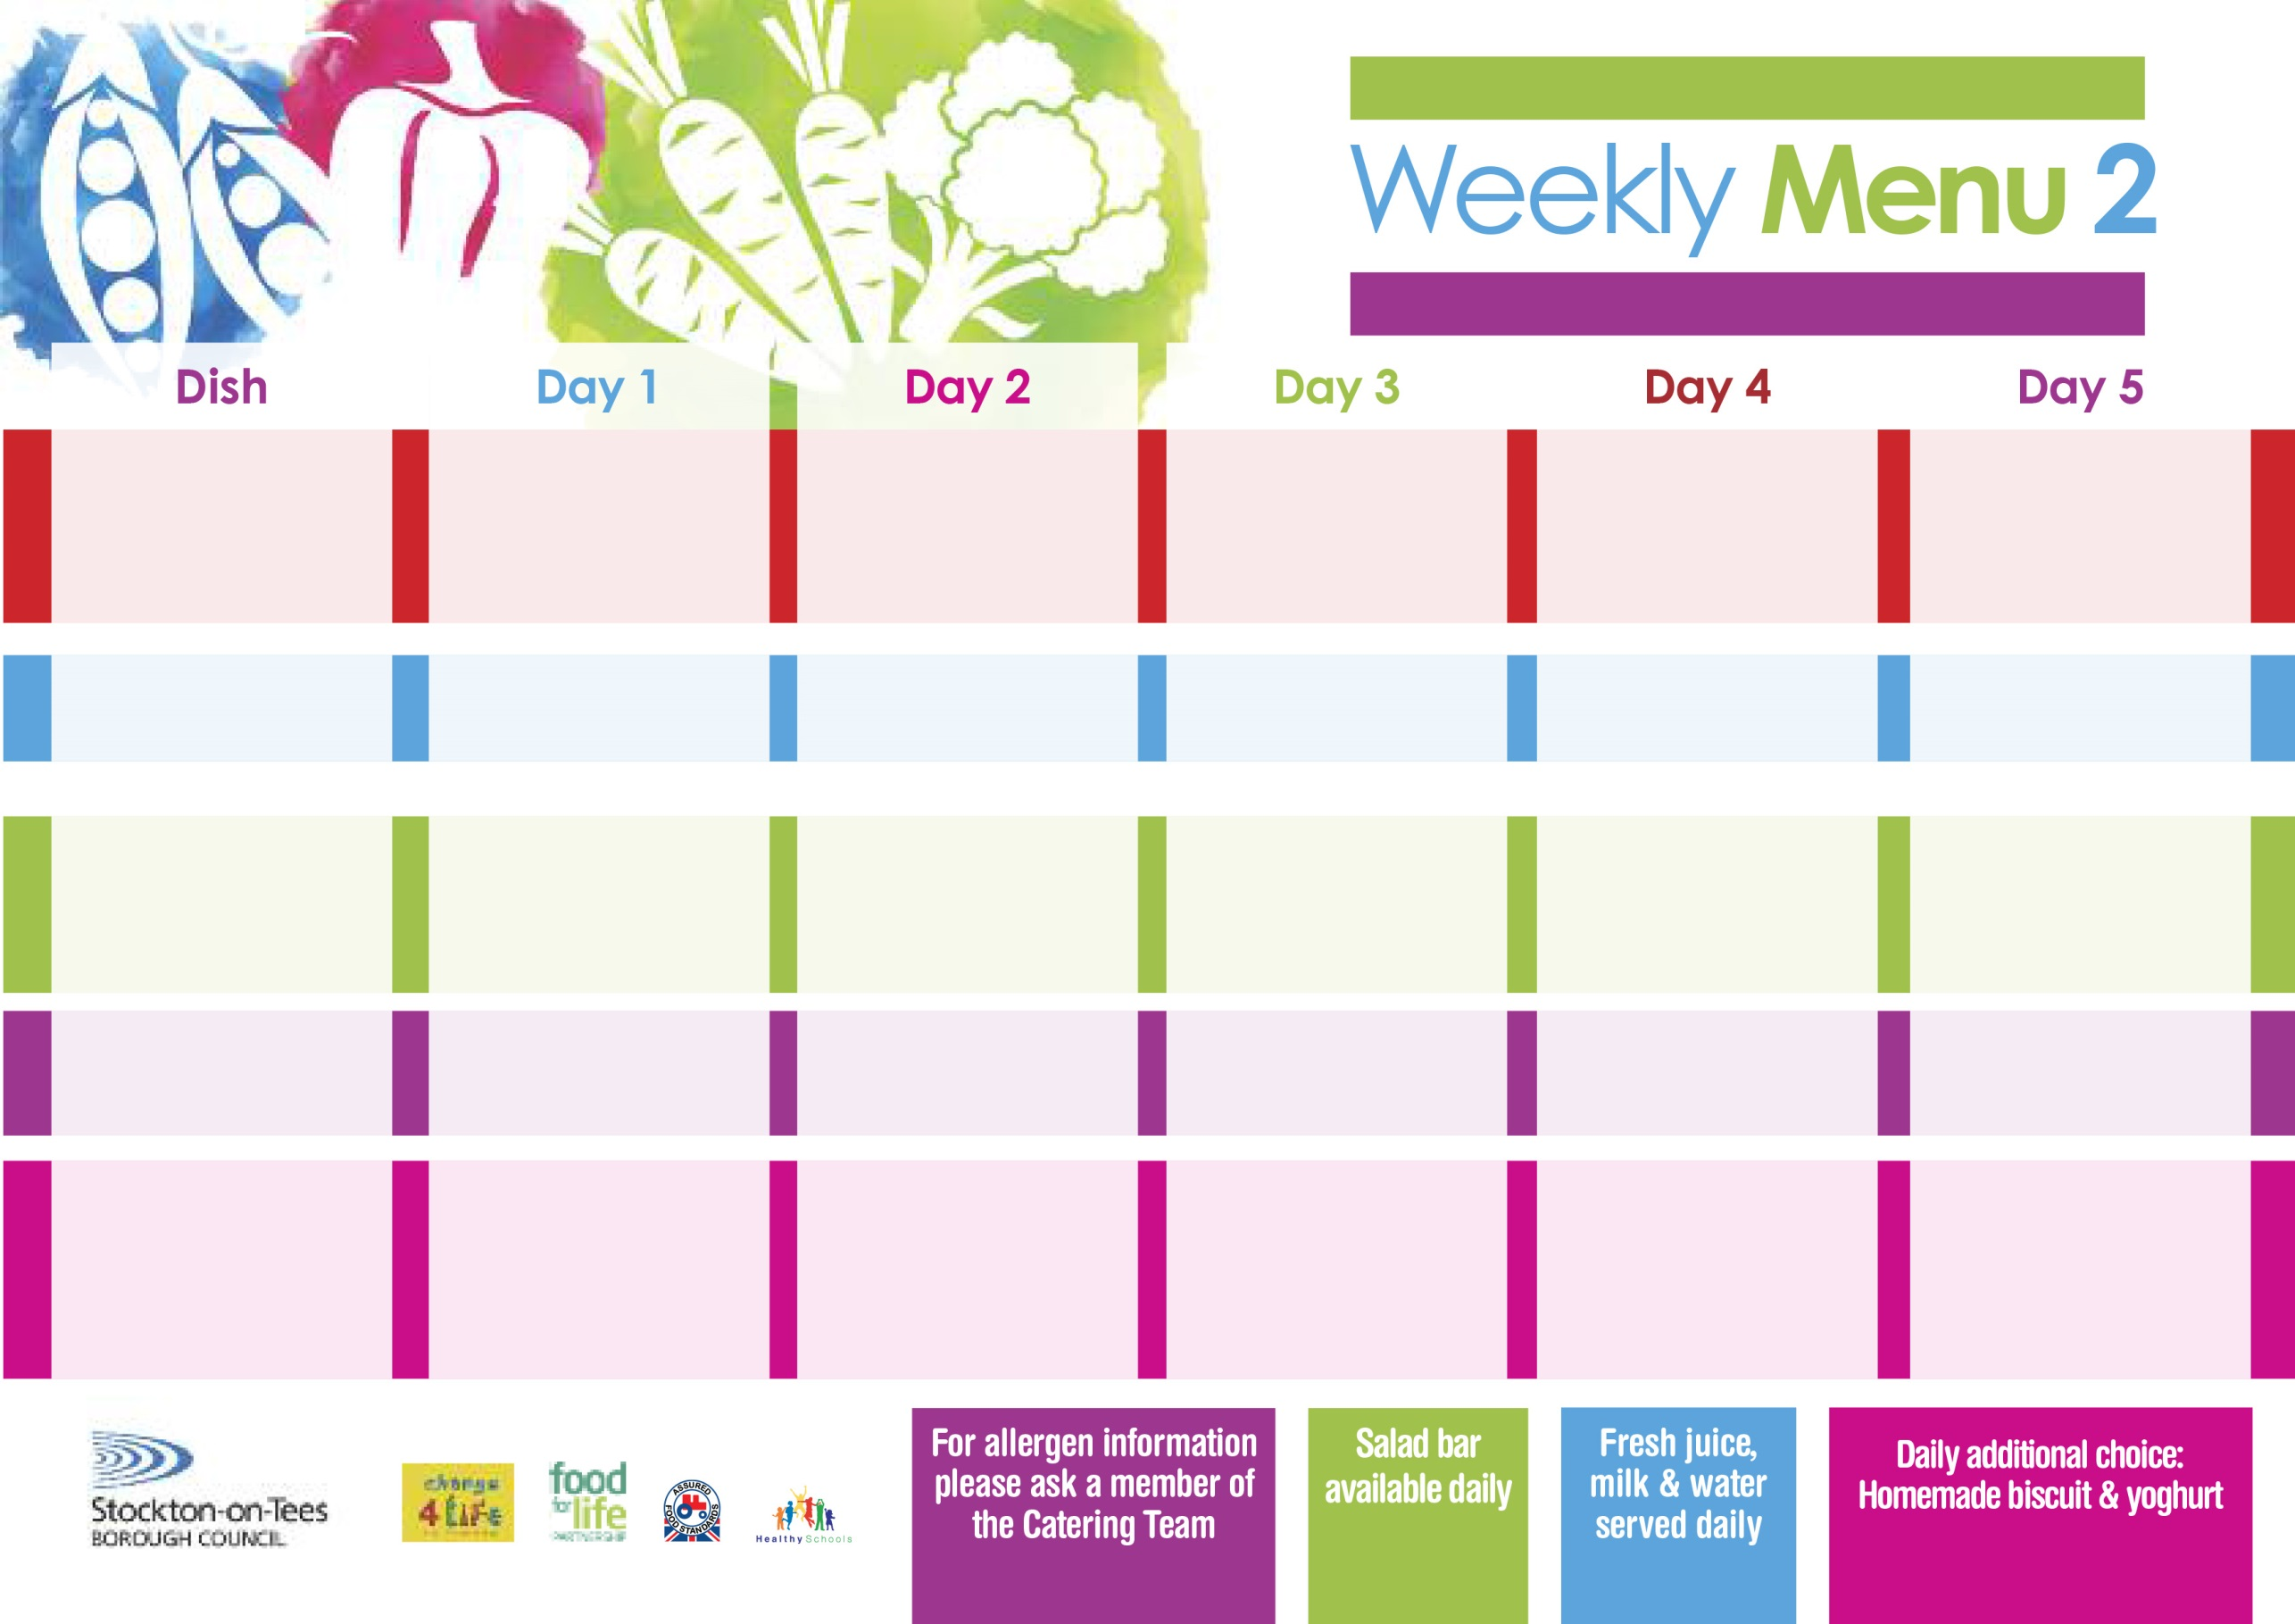

**22nd April, 20th May, 24th June & 22nd July, 2024**

**Homemade Pizza (V)**

**Baked Potato Wedges**

**Garden Peas**

**Spaghetti Hoops**

**Penne Pasta in**

**Tomato Sauce (V)**

**Homemade Herby Bread**

**Garden Peas**

**Tuna Sandwich**

**Baked Potato Wedges**

**Chocolate Chip Sponge**

**with Custard Sauce**

**Cold Bar**

**Fresh Fruit Bowl**

**Roast Gammon & Pineapple**

**Baby Boiled Potatoes**

**Sweetcorn**

**Diced Carrots**

**Cheese & Onion Roll (V)**

**Baby Boiled Potatoes**

**Sweetcorn**

**Tuna Sandwich**

**Baby Boiled Potatoes**

**Ginger Sponge**

**with Custard Sauce**

**Cold Bar**

**Fresh Fruit Salad**

**Minced Beef Cobbler**

**Oven Roasted Potatoes**

**Broccoli**

**Swede**

**Quorn Mince Cobbler (V)**

**Fish Star**

**Oven Roasted Potatoes**

**Spaghetti Hoops**

**Ham Sandwich**

**Oven Roasted Potatoes**

**Apple Pie**

**with Custard Sauce**

**Cold Bar**

**Fresh Fruit Bowl**

**Fish Goujons**

**Oven Baked Chips**

**Garden Peas**

**Baked Beans**

**Jacket Potato filled with**

**Tuna, Cheese (V)**

**or Baked Beans (V)**

**with Tossed Salad**

**Egg Mayonnaise Sandwich**

**(V)**

**Oven Baked Chips**

**Creamy Rice Pudding**

**with Jam Sauce**

**Cold Bar**

**Fresh Fruit Bowl**

**Chicken Pie**

**Creamed Potatoes**

**Diced Carrots**

**Cauliflower**

**Quorn Sausages in a Bun (V)**

**Sausage in a Bun**

**Baked Jacket Potatoes**

**Baked Beans**

**Cheese Sandwich (V)**

**Baked Jacket Potatoes**

**Jam Roly Poly**

**with Custard Sauce**

**Cold Bar**

**Fresh Fruit Salad**

**Wristband Primary School Menu**

**Red Choice**

**Blue Choice**

**Green Choice**

**Cold Selection**

**Desserts**