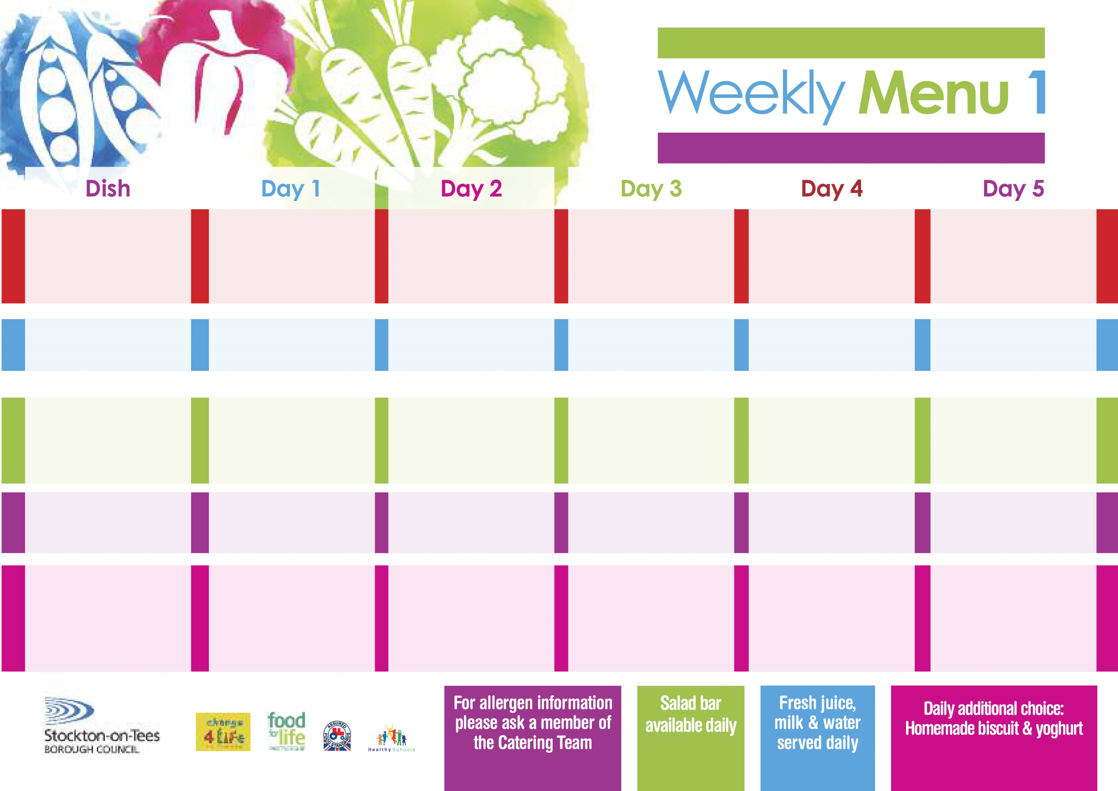

**Harry Ramsden Fish Fillet**

**Oven Baked Chips**

**Garden Peas**

**Baked Beans**

**Homemade Quiche (V)**

**Oven Baked Chips**

**Garden Peas**

**Baked Beans**

**Cheese Sandwich (V)**

**Oven Baked Chips**

**Creamy Rice Pudding**

**with Jam Sauce**

**Cold Bar**

**Fresh Fruit Bowl**

**15th April, 13th May, 17th June & 15th July, 2024**

**Minced Beef Pie**

**Oven Roasted Potatoes**

**Diced Carrots**

**Broccoli**

**Quorn Mince Pie (V)**

**Cheese Omelette (V)**

**Oven Roasted Potatoes**

**Diced Carrots**

**Broccoli**

**Egg Mayonnaise Sandwich**

**(V)**

**Oven Roasted Potatoes**

**Apple Crumble**

**with Custard Sauce**

**Cold Bar**

**Fresh Fruit Salad**

**Homemade Pizza (V)**

**Baked Potato Wedges**

**Baked Beans**

**Jacket Potato filled with Tuna, Cheese (V)**

**or Baked Beans (V)**

**with Tossed Salad & Coleslaw**

**Tuna Sandwich**

**Baked Potato Wedges**

**Chocolate Sponge**

**with Custard Sauce**

**Cold Bar**

**Fresh Fruit Bowl**

**Spaghetti Bolognaise**

**Homemade Garlic Bread**

**Mixed Vegetables**

**Quorn Bolognaise (V)**

**Mini Cheese**

**& Onion Slice (V)**

**Baked Jacket Potato**

**Spaghetti Hoops**

**Ham Sandwich**

**Baked Jacket Potato**

**Bakewell Tart**

**with Custard Sauce**

**Cold Bar**

**Fresh Fruit Salad**

**Wristband Primary School Menu**

**+**

**Toad in the Hole**

**Baby Boiled Potatoes**

**Sweetcorn/Garden Peas**

**Quorn Sausage with Yorkshire Pudding (V)**

**Fish Fillet Fingers**

**Baby Boiled Potatoes**

**Sweetcorn/Garden Peas**

**Cheese Sandwich (V)**

**Baked Boiled Potatoes**

**Jam Sponge**

**with Custard Sauce**

**Cold Bar**

**Fresh Fruit Bowl**

**Red Choice**

**Blue Choice**

**Green Choice**

**Cold Selection**

**Desserts**