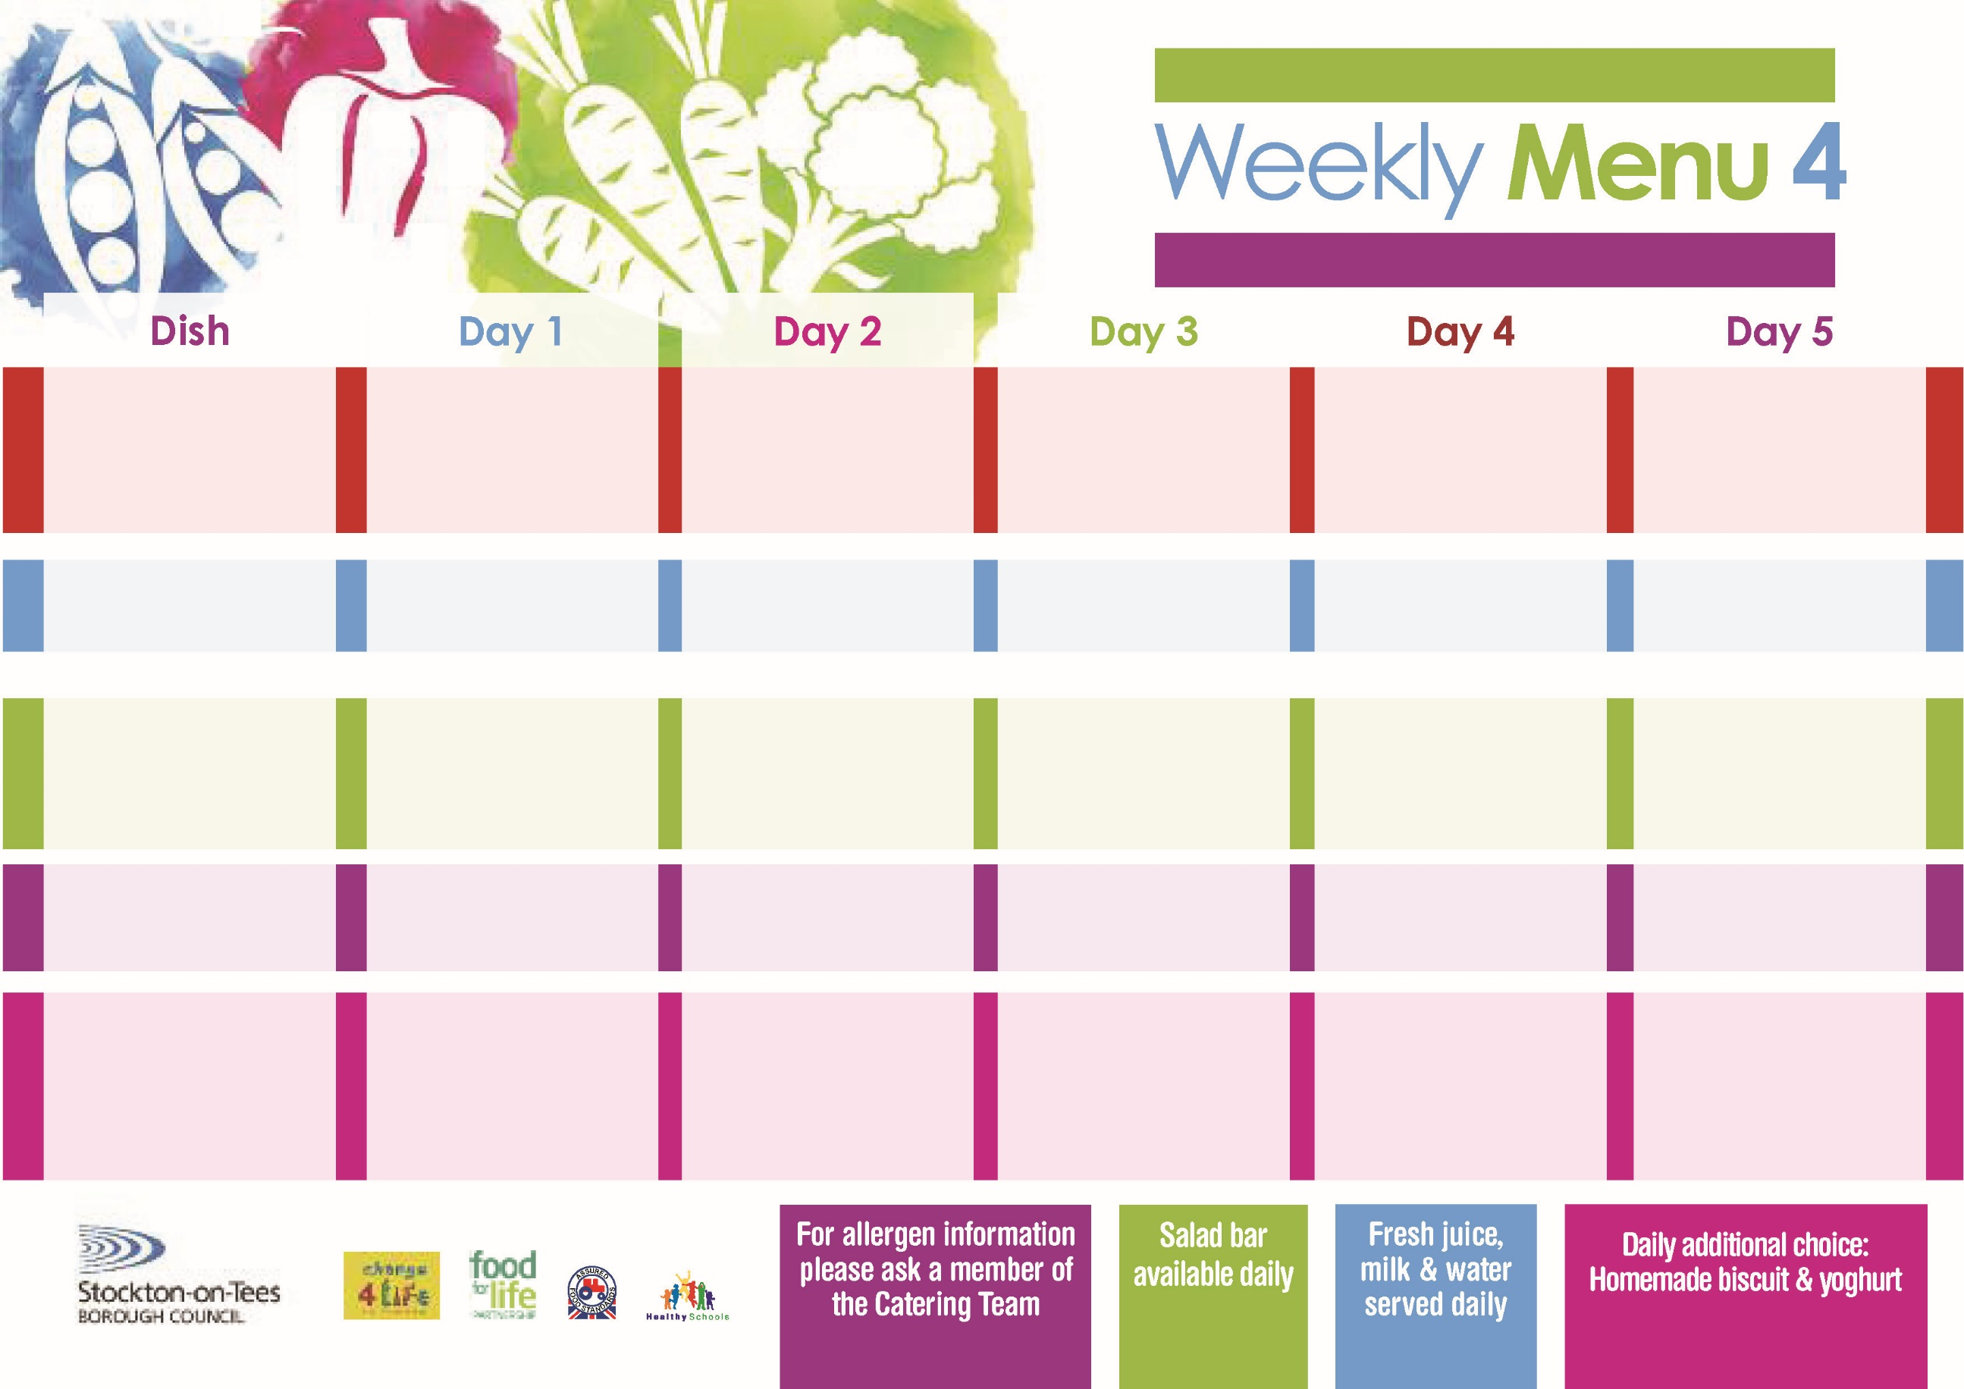

**25th September, 23rd October & 27th November, 2023**

**Fish Goujons**

**Oven Baked Chips**

**Garden Peas**

**Baked Beans**

**Baked Cheese & Onion Roll**

**(V)**

**Sausage Roll**

**Oven Baked Chips**

**Garden Peas**

**Baked Beans**

**Cheese Sandwich (V)**

**Oven Baked Chips**

**Chocolate Lime Sponge**

**with Custard Sauce**

**Cold Bar**

**Fresh Fruit Bowl**

**Roast Turkey served with Sage & Onion Stuffing**

**Creamed Potatoes**

**Diced Swede**

**Cabbage**

**Jacket Potato filled with**

**Tuna, Cheese (V)**

**or Baked Beans (V)**

**Egg Mayo Sandwich (V)**

**Baked Jacket Potatoes**

**Creamy Rice Pudding**

**with Jam Sauce**

**Cold Bar**

**Fresh Fruit Salad**

**Sweet & Sour Pork**

**& Rice**

**Mixed Vegetables**

**Quorn Sausage in a Bun (V)**

**Sausage in a Bun**

**Baked Potato Wedges**

**Spaghetti Hoops**

**Cheese Sandwich** **(V)**

**Baked Potato Wedges**

**Festival Shortcake**

**with Custard Sauce**

**Cold Bar**

**Fresh Fruit Bowl**

**Mediterranean Bolognaise with Pasta Twists**

**Homemade Garlic Bread**

**Broccoli / Sweetcorn**

**Quorn Bolognaise (V)**

**Pizza (V)**

**Oven Roasted Potatoes**

**Broccoli /Sweetcorn**

**Tuna Sandwich**

**Oven Roasted Potatoes**

**Oaty Apple Crumble**

**with Custard Sauce**

**Cold Bar**

**Fresh Fruit Salad**

**Chicken Cobbler**

**Creamed Potatoes**

**Diced Carrots**

**Cauliflower**

**Diced Quorn Cobbler (V)**

**Fish Cake**

**Baked Jacket Potato**

**Baked Beans**

**Egg Mayo Sandwich (V)**

**Baked Jacket Potatoes**

**Syrup Sponge**

**with Custard Sauce**

**Cold Bar**

**Fresh Fruit Bowl**

**Red Choice**

**Blue Choice**

**Green Choice**

**Cold Selection**

**Desserts**

**Wristband Primary School Menu**