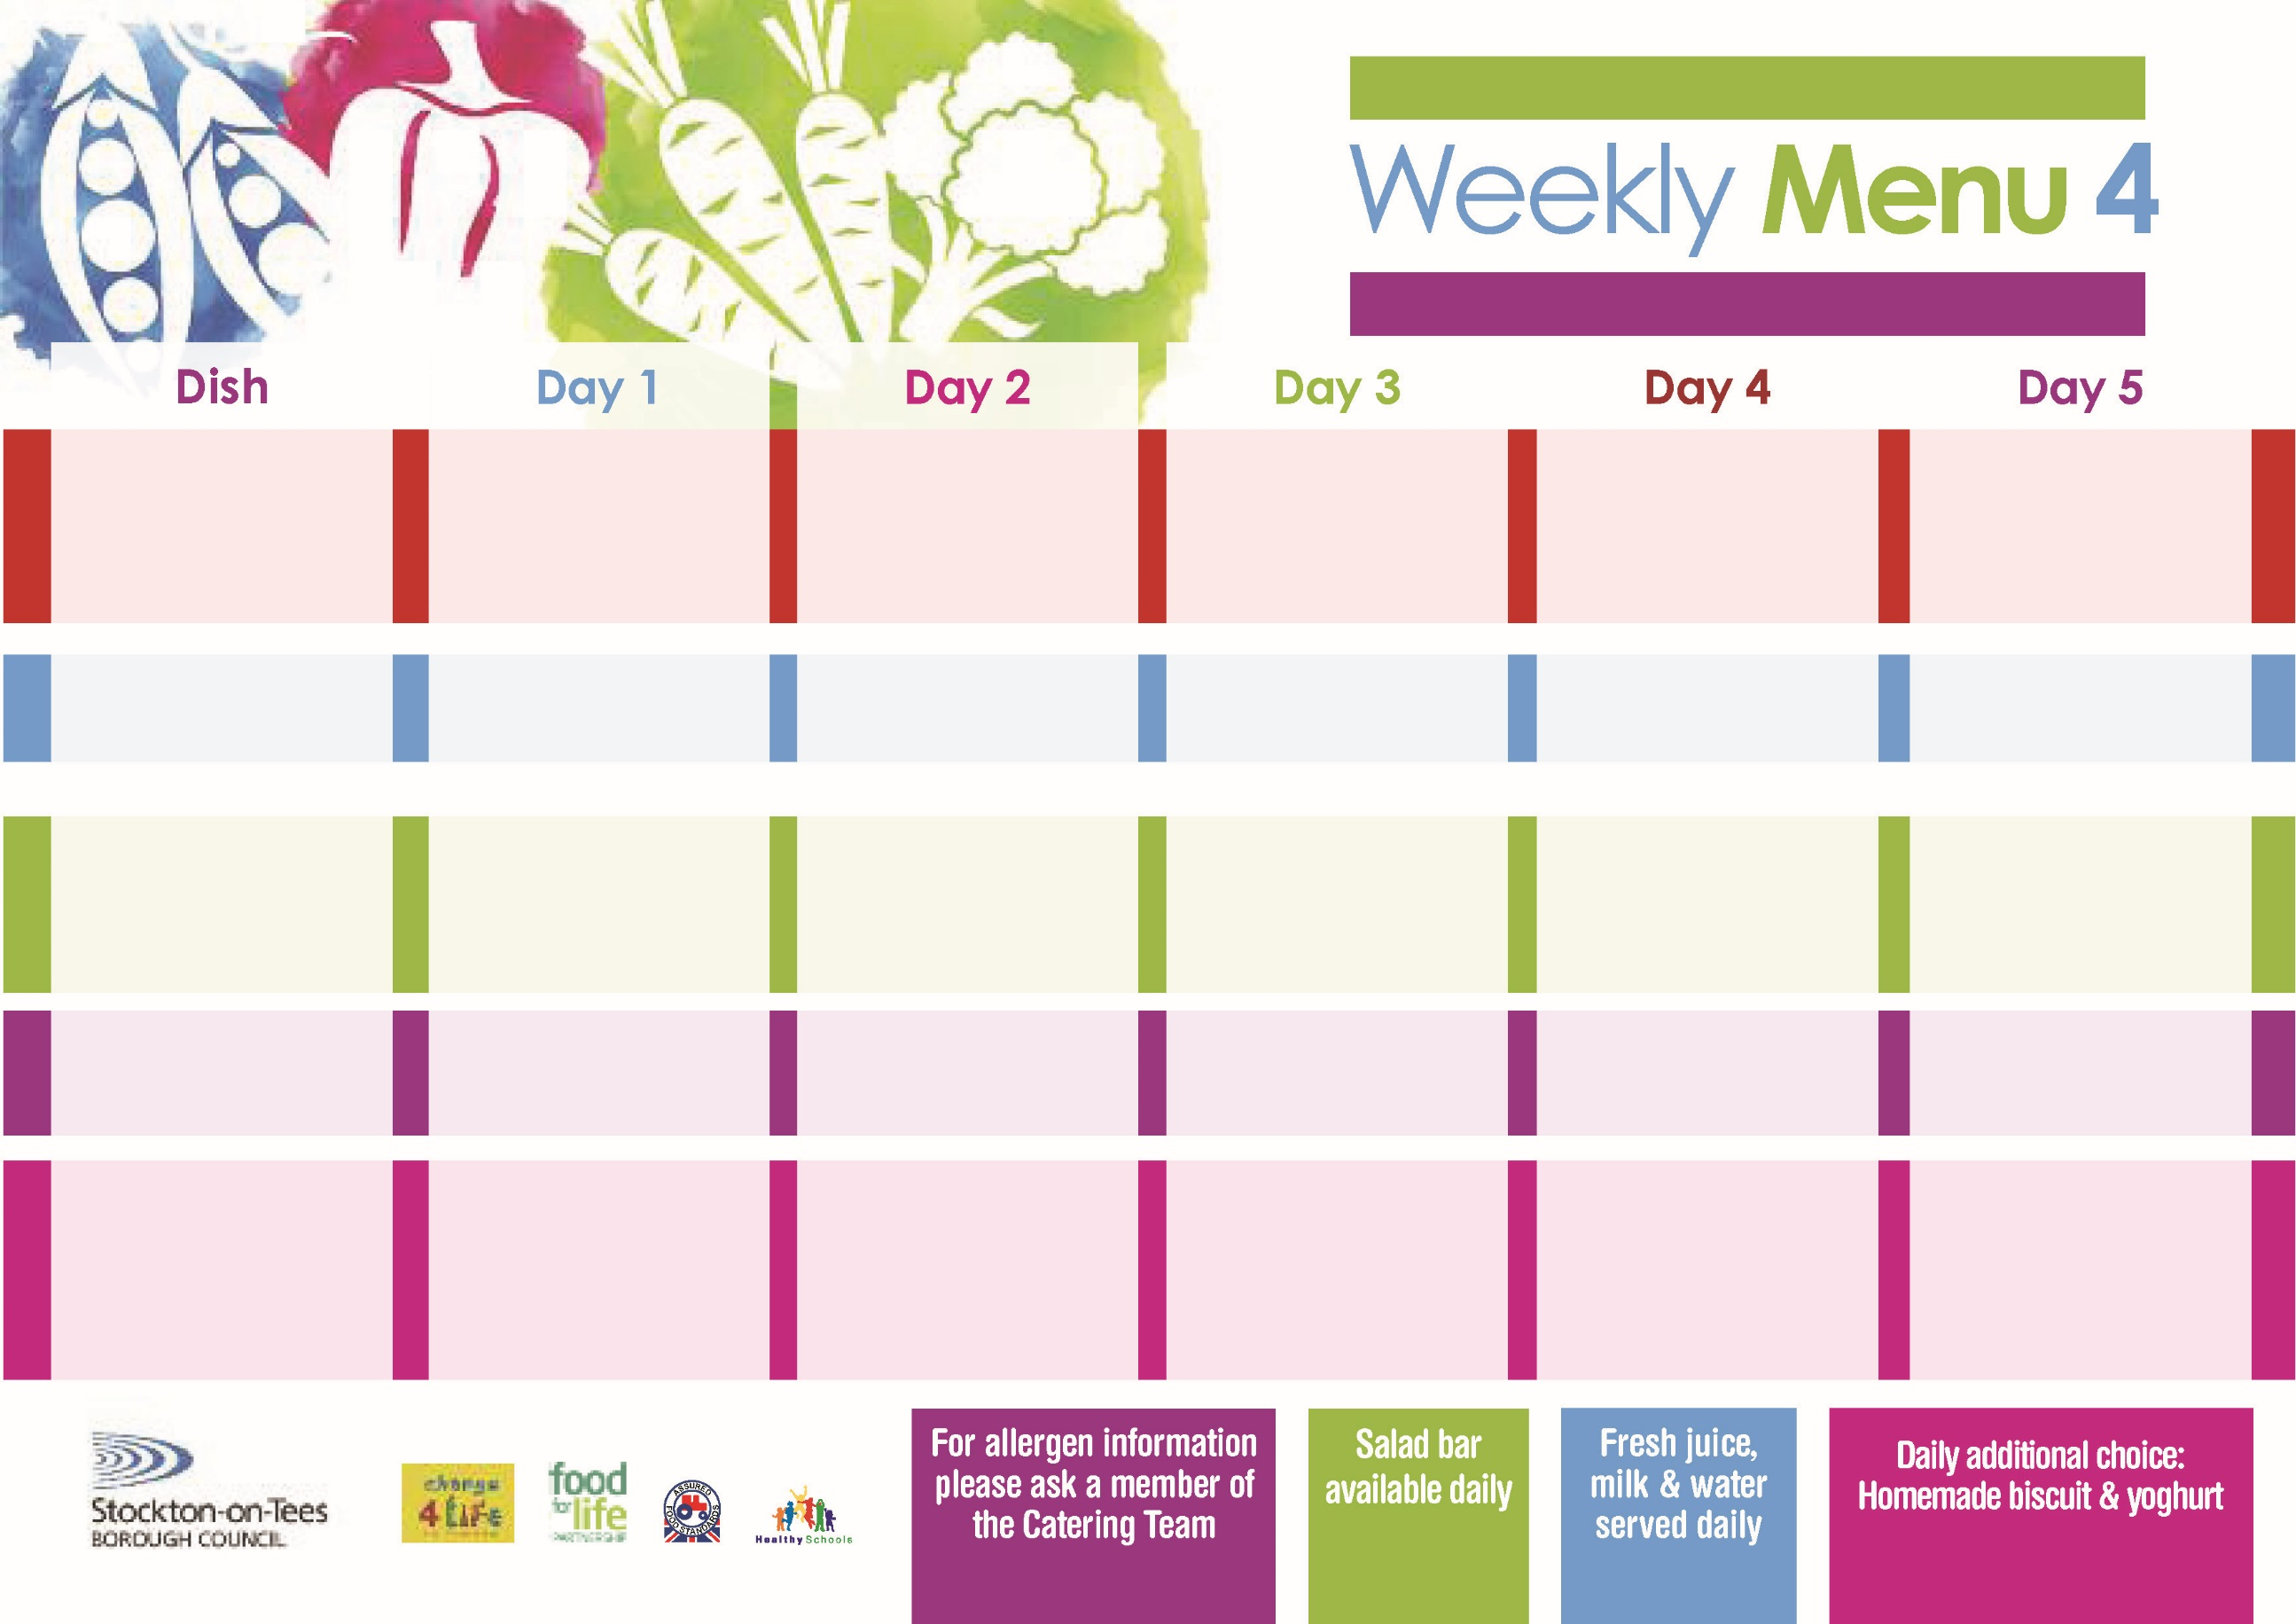

**22nd January, 26th February & 25th March, 2024**

**Harry Ramsden Fish Fillet**

**Oven Baked Chips**

**Garden Peas**

**Baked Beans**

**Mini Cheese & Onion Slice (V)**

**Oven Baked Chips**

**Garden Peas**

**Baked Beans**

**Ham Sandwich**

**Oven Baked Chips**

**Bakewell Tart**

**with Custard Sauce**

**Cold Bar**

**Fresh Fruit Bowl**

**Roast Beef served with Yorkshire Pudding**

**Creamed Potatoes**

**Broccoli**

**Diced Carrots**

**Fish Fillet Fingers**

**Creamed Potatoes**

**Broccoli**

**Diced Carrots**

**Cheese Sandwich (V)**

**Baked Jacket Potatoes**

**Orange Sponge**

**with Custard Sauce**

**Cold Bar**

**Fresh Fruit Salad**

**Cheese & Tomato Pizza (V)**

**Oven Roasted Potatoes**

**Baked Beans**

**Sweetcorn**

**Penne Pasta in**

**Tomato Sauce (V)**

**Homemade Garlic Bread**

**Sweetcorn**

**Egg Mayo Sandwich** **(V)**

**Oven Roasted Potatoes**

**Creamy Rice Pudding**

**with Jam Sauce**

**Cold Bar**

**Fresh Fruit Bowl**

**Chicken Curry served**

**with Rice**

**Mixed Vegetables**

**Quorn Curry** **(V)**

**Sausage Roll**

**Baked Jacket Potatoes**

**Spaghetti Hoops**

**Tuna Sandwich**

**Baked Jacket Potatoes**

**Chocolate Lime**

**with Custard Sauce**

**Cold Bar**

**Fresh Fruit Salad**

**Cumberland Sausages**

**Creamed Potatoes**

**Cabbage**

**Cauliflower**

**Baked Quorn Sausages (V)**

**Jacket Potato filled with**

**Tuna, Cheese (V)**

**or Baked Beans (V)**

**Egg Mayo Sandwich (V)**

**Baked Jacket Potatoes**

**Jam Sponge**

**with Custard Sauce**

**Cold Bar**

**Fresh Fruit Bowl**

**Red Choice**

**Blue Choice**

**Green Choice**

**Cold Selection**

**Desserts**

**Wristband Primary School Menu**