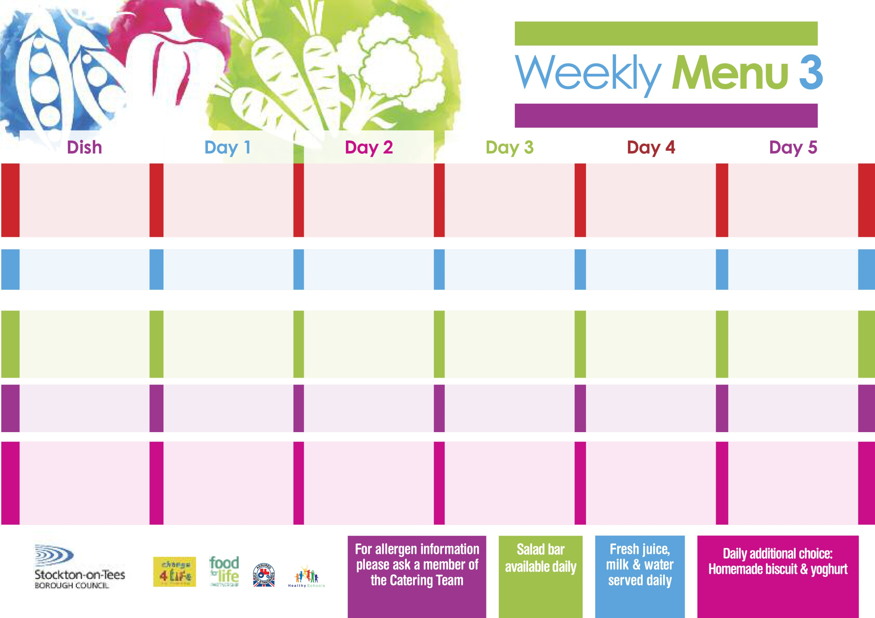

**Lasagne**

**Homemade Garlic Bread**

**Mixed Vegetables**

**Quorn Lasagne (V)**

**Jacket Potato filled with**

**Tuna, Cheese (V)**

**or Baked Beans (V)**

**Ham Sandwich**

**Baked Jacket Potatoes**

**Ginger Sponge**

**with Custard Sauce**

**Cold Bar**

**Fresh Fruit Salad**

**18th September, 16th October, 20th November & 18th December, 2023**

**Harry Ramsden Fish Fillet**

**Oven Baked Chips**

**Garden Peas**

**Baked Beans**

**Homemade Quiche** **(V)**

**Oven Baked Chips**

**Garden Peas**

**Baked Beans**

**Cheese Sandwich (V)**

**Oven Baked Chips**

**Creamy Rice Pudding**

**with Jam Sauce**

**Cold Bar**

**Fresh Fruit Bowl**

**Chicken Curry & Rice**

**Garden Peas**

**Cauliflower**

**Homemade Pizza (V)**

**Baked Potato wedges**

**Spaghetti Hoops**

**Tuna Sandwich**

**Baked Potato Wedges**

**Chocolate Crunch**

**with Custard Sauce**

**Cold Bar**

**Fresh Fruit Bowl**

**Roast Gammon & Pineapple**

**Oven Roasted Potatoes**

**Broccoli**

**Diced Carrots**

**Cheese Omelette (V)**

**Oven Roasted Potatoes**

**Broccoli**

**Diced Carrots**

**Egg Mayo Sandwich (V)**

**Oven Roasted Potatoes**

**Syrup Roly Poly**

**with Custard Sauce**

**Cold Bar**

**Fresh Fruit Salad**

**Baked Cumberland Sausages**

**Oven Roasted Potatoes**

**Sweetcorn**

**Diced Carrots**

**Salmon & Sweet Potato Fishcake**

**Oven Roasted Potatoes**

**Sweetcorn**

**Diced Carrots**

**Cheese Sandwich (V)**

**Oven Roasted Potatoes**

**Jam Sponge**

**with Custard Sauce**

**Cold Bar**

**Fresh Fruit Bowl**

**Red Choice**

**Blue Choice**

**Green Choice**

**Cold Selection**

**Desserts**

**Wristband Primary School Menu**