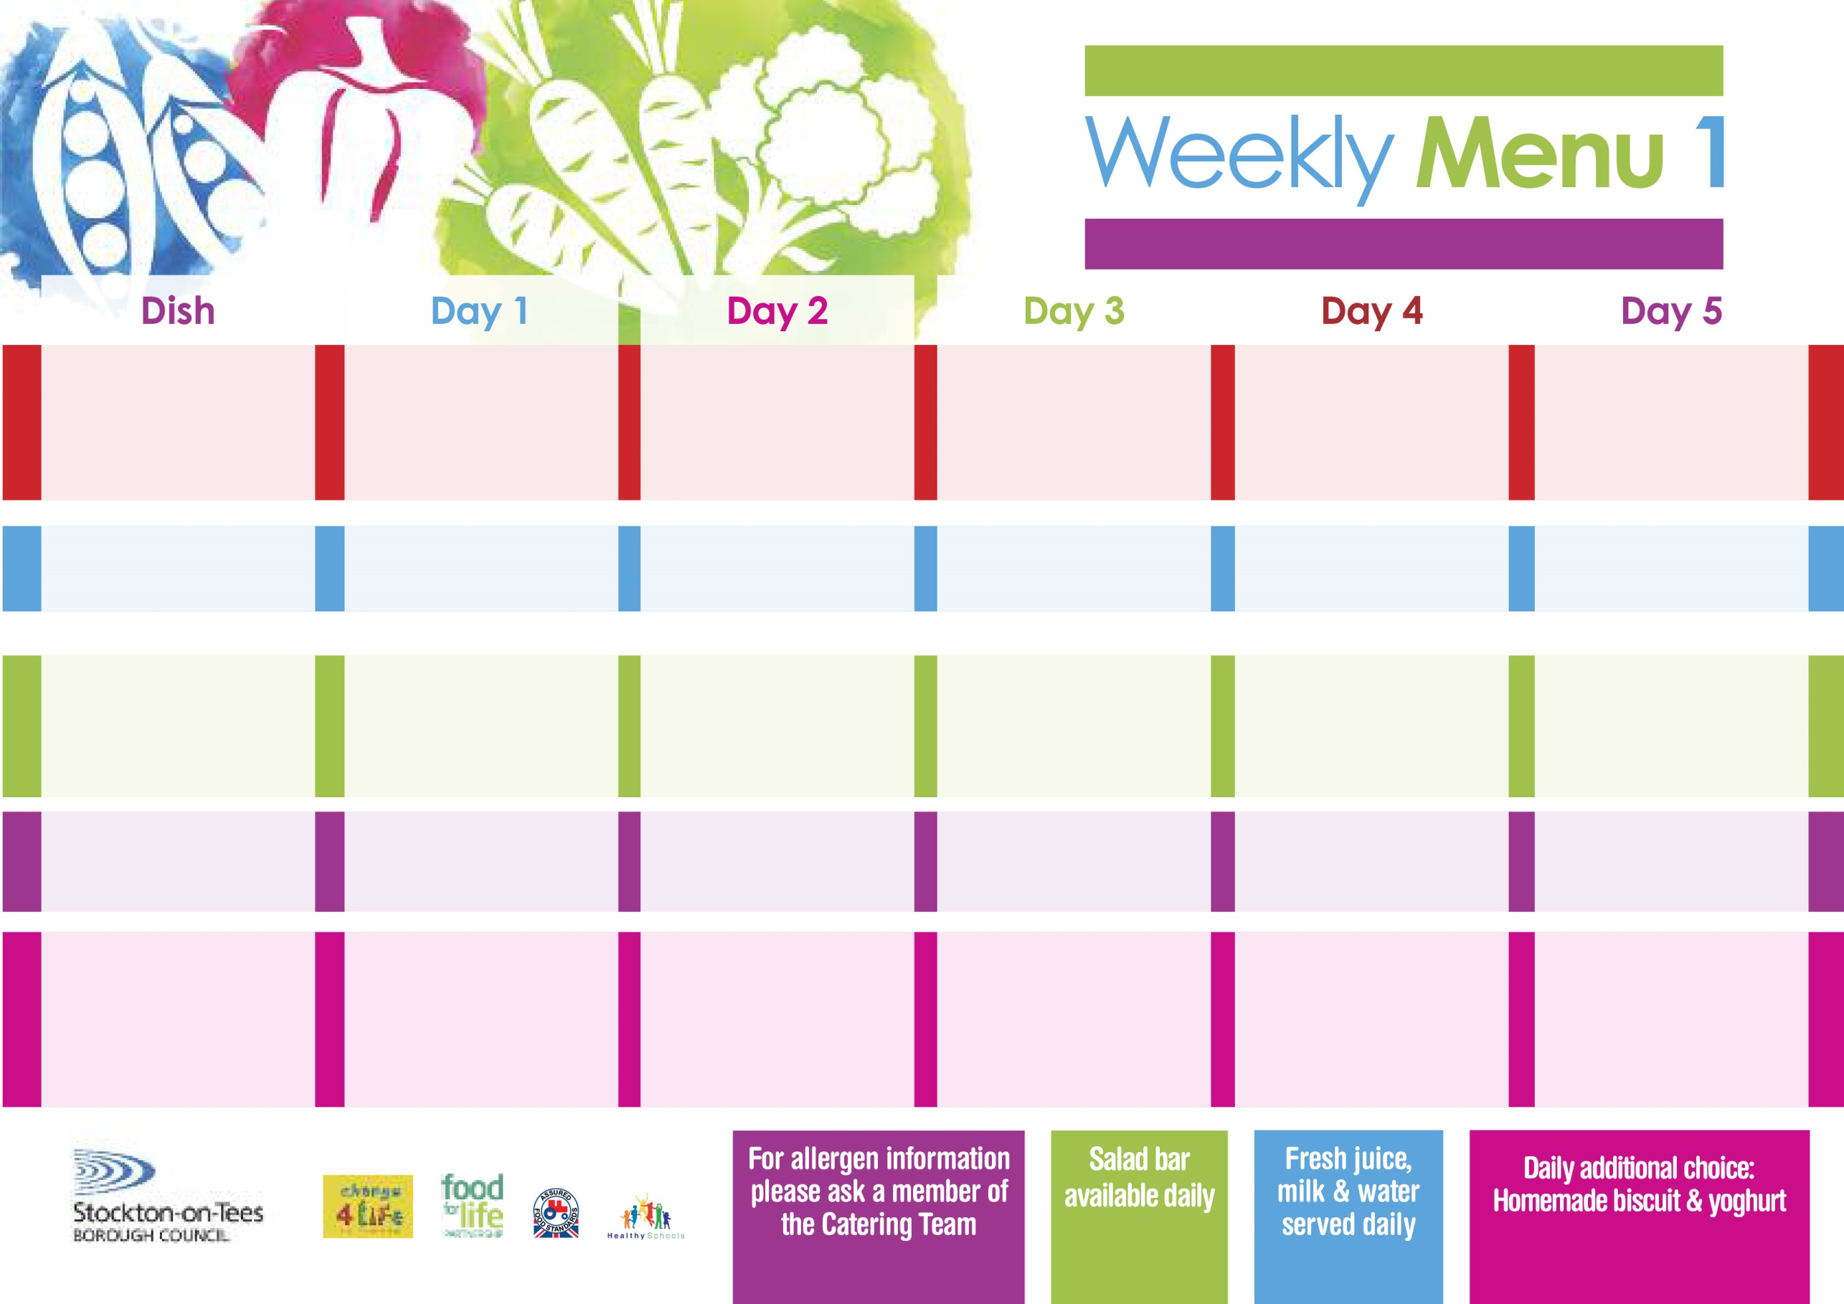

**Spaghetti Bolognaise**

**Homemade Garlic Bread**

**Mixed Vegetables**

**Quorn Bolognaise**

**Homemade Garlic Bread (V)**

**Cheese & Onion Roll (V)**

**Baked Jacket Potatoes**

**Baked Beans**

**Tuna Sandwich**

**Baked Jacket Potatoes**

**Jam Roly Poly**

**with Custard Sauce**

**Cold Bar**

**Fresh Fruit Salad**

**Chicken & Vegetables with Puff Pastry Lid**

**Roast Potatoes**

**Cabbage/Cauliflower**

**Fish Star**

**Oven Roasted Potatoes**

**Spaghetti Hoops**

**Cheese Sandwich (V)**

**Oven Roasted Potatoes**

**Apple Crumble**

**with Custard Sauce**

**Cold Bar**

**Fresh Fruit Bowl**

**4th September, 2nd October, 6th November & 4th December, 2023**

**Mince & Yorkshire Puddings**

**Creamed Potatoes**

**Diced Carrots/Green Beans**

**Penne Pasta in**

**Tomato Sauce (V)**

**Homemade Herby Bread**

**Diced Carrots/ Green Beans**

**Tuna Sandwich**

**Baked Jacket Potato**

**Vanilla Sponge**

**with Custard Sauce**

**Cold Bar**

**Fresh Fruit Salad**

**Wristband Primary School Menu**

**+**

**Pork & Carrot Meatballs in Tomato Sauce with Pasta & Homemade Garlic Bread**

**Broccoli/ Sweetcorn**

**Quorn Meatballs in Tomato**

**Sauce with Pasta (V) Homemade Garlic Bread**

**Jacket Potato filled with Tuna, Cheese (V) or Baked Beans (V)**

**Egg Mayonnaise Sandwich**

**(V)**

**Baked Jacket Potatoes**

**Chocolate Sponge**

**with Custard Sauce**

**Cold Bar**

**Fresh Fruit Bowl**

**Harry Ramsden Fish Fillet**

**Oven Baked Chips**

**Garden Peas**

**Baked Beans**

**Homemade Pizza (V)**

**Oven Baked Chips**

**Garden Peas**

**Baked Beans**

**Egg Mayonnaise Sandwich (V)**

**Oven Baked Chips**

**Creamy Rice Pudding**

**with Jam Sauce**

**Cold Bar**

**Fresh Fruit Bowl**

**Red Choice**

**Blue Choice**

**Green Choice**

**Cold Selection**

**Desserts**