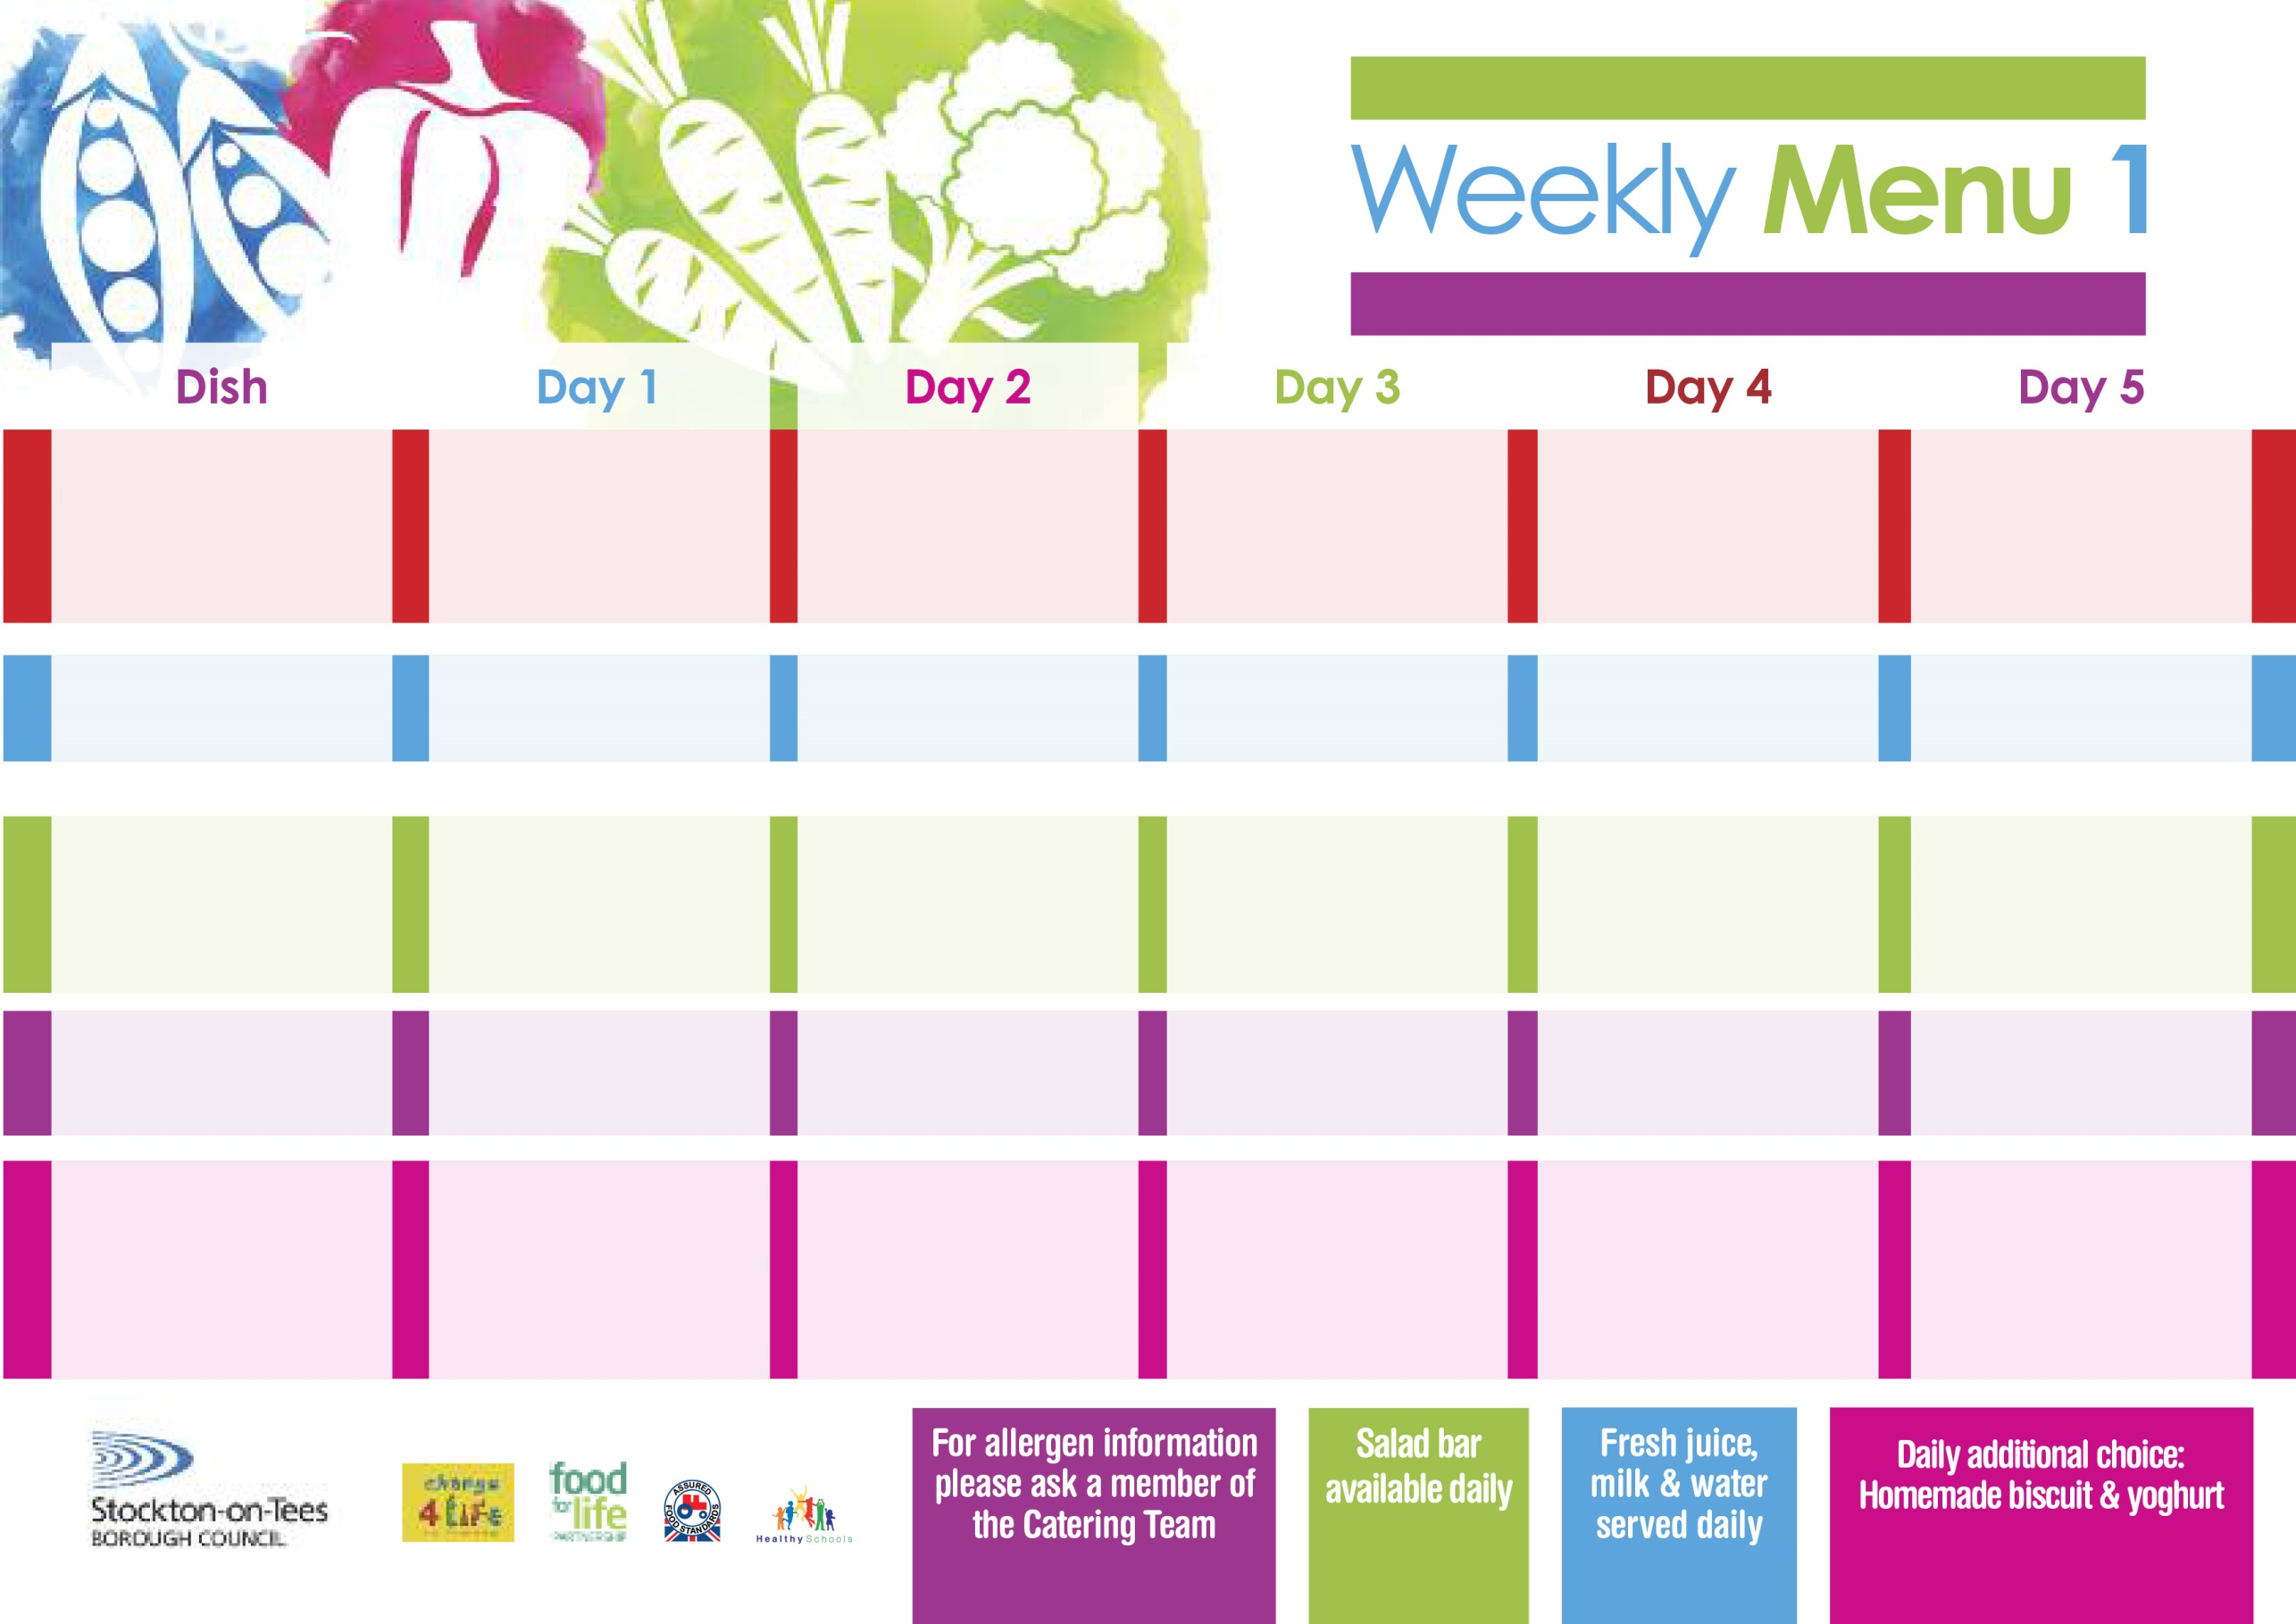

**Harry Ramsden Fish Fillet**

**Oven Baked Chips**

**Garden Peas**

**Baked Beans**

**Jacket Potato filled with Tuna, Cheese (V)**

**or Baked Beans (V)**

**Egg Mayonnaise Sandwich (V)**

**Oven Baked Chips**

**Vanilla Sponge**

**with Custard Sauce**

**Cold Bar**

**Fresh Fruit Bowl**

**1st January, 29th January & 4th March, 2024**

**Mince & Dumplings**

**Baby Boiled Potatoes**

**Diced Carrots**

**Cauliflower**

**Quorn Mince & Dumplings (V)**

**Fish Stars**

**Baby Boiled Potatoes**

**Diced Carrots**

**Cauliflower**

**Tuna Sandwich**

**Baby Boiled Potatoes**

**Apple Crumble**

**with Custard Sauce**

**Cold Bar**

**Fresh Fruit Salad**

**Leek & Mushroom Pasta Bake (V)**

**Homemade Garlic Bread**

**Broccoli**

**Mixed Vegetables**

**Homemade Pizza (V)**

**Baked Potato Wedges**

**Baked Beans**

**Egg Mayonaise Sandwich (V)**

**Baked Potato Wedges**

**Ginger Sponge**

**with Custard Sauce**

**Cold Bar**

**Fresh Fruit Bowl**

**Roast Gammon served with Pineapple**

**Baked Jacket Potato**

**Tossed Salad & Coleslaw**

**Mini Cheese & Onion Slice (V)**

**Baked Jacket Potato**

**Spaghetti Hoops**

**Tuna Sandwich**

**Baked Jacket Potato**

**Chocolate Crunch**

**with Custard Sauce**

**Cold Bar**

**Fresh Fruit Salad**

**Wristband Primary School Menu**

**+**

**Breaded Chicken Breast**

**Oven Roasted Potatoes**

**Sweetcorn**

**Garden Peas**

**Quorn Dippers** **(V)**

**Corned Beef Pie**

**Oven Roasted Potatoes**

**Sweetcorn**

**Garden Peas**

**Cheese Sandwich (V)**

**Oven Roasted Potatoes**

**Chocolate Sponge**

**with Custard Sauce**

**Cold Bar**

**Fresh Fruit Bowl**

**Red Choice**

**Blue Choice**

**Green Choice**

**Cold Selection**

**Desserts**